Nebraska Wesleyan University

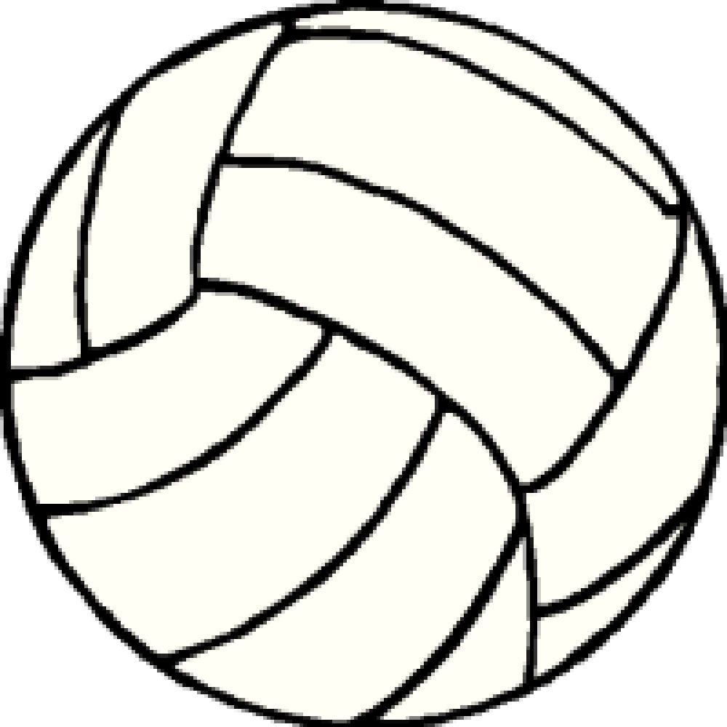
NWU Showdown - 2022

17U Division

START TIME: 8:00 AM

Sunday, March 27th

Warm-ups will be 2 minutes of shared court time, followed by 4 min of hitting for the serving team
and 4 min of hitting for the receiving team.
Warm-ups can be shortened to 1-3-3 after each team’s first match.
Serving is to be completed during each team’s court time. THERE IS NO SHARED SERVING

Pool play will be 2 sets to 25 points, starting at 7.

Pool A Pool B
1. Great Plains 17 Gold 1. Great Plains 17 Silver
2. Southeast Grays 17 2. Kill Club 17
3. Centennial 17 3. Cardinal Club 17

Time  (Approx.) | Ct 1 | Ref | Ct 2 | Ref
8:00 AM | A1 vs A3 | A2 | B1 vs B3 | B2
8:45 AM | A2 vs A3 | A1 | B2 vs B3 | B1
 | A1 vs A2 | A3 | B1 vs B2 | B3
 | CH1) B2 vs A3 | A1 | CH2) A2 vs B3 | B1
 | CH3) A1 vs wnr CH1 | lsr CH1 | CH4) B1 vs wnr CH2 | lsr CH2
 | CH6) lsr CH3 vs lsr CH4 *If see note | wnr CH3 | CH5) lsr CH1 vs lsr CH2 | wnr/lsr CH4**
 | CH7) wnr CH3 vs wnr CH4 | lsr CH3/6** | XXXXX | XX

TEAMS WILL BE ASSIGNED TO TOURNAMENTS BY THE FOLLOWING METHOD:
- BEST SET (games) RECORD
- HEAD TO HEAD COMPETITION (to include point differential)
- TOTAL POINT DIFFERENTIAL
- A COIN TOSS, IF NECESSARY

INDIVIDUAL PRIZES WILL BE AWARDED TO FIRST-PLACE TEAM IN THE TOURNAMENT

Nebraska Wesleyan University

NWU Showdown - 2022

17U Division

Sunday, March 27th

All tournament matches will be best 2 out of 3 sets to 25 points, starting at 7. Third set 0-15, if necessary.

 |  |  |  |  |  |  | A#1
 |  |  |  |  |  |  | CH3)
 |  |  |  |  |  | A#3 | lsr CH1 ref
 |  |  |  |  |  | CH1)
 |  |  |  |  |  | A#1 ref
 |  |  |  |  | CH5) | B#2 |  | CH7)
 |  |  |  |  | wnr or lsr  of CH4 ref**(see note) |  |  | lsr CH3 or CH6 ref** | CHAMPION
 |  | CH6)
 |  | wnr CH3 ref |  |  |  | B#3
*Only played if A#1 or B#1 loses their first match |  |  |  |  |  | CH2)
 |  |  |  |  |  | B#1 ref
 |  |  |  |  |  |  | CH4)
 |  |  |  |  |  | A#2 | lsr CH2 ref
**NOTE: If A#1 and B#1 win their first match, CH7) can be moved up into the CH6) timeslot. Then the lsr of CH3) would ref the CH7) match and the lsr of CH4) would ref the CH5) match.

 |  |  |  |  |  |  | B#1

