6th Grade Qualifying Tournament
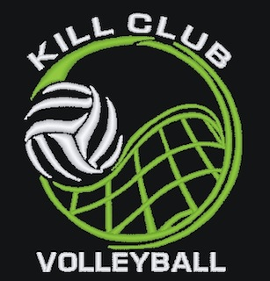
Sunday, March 12, 2023
West Monona HS, 1314 15th St., Onawa, Iowa

**Play begins at 12:00, noon. Gym will be available at 11:15**

ROUND 1

POOL A POOL B POOL C
1. Blue Fury 1. Rampage 1. Carroll Tigers
2. Raptors 2. Glenwood Black 2. Kill Club
3. NIVA 3. AA Warriors 3. SC Moons

COURT 1 COURT 2 COURT 3
REF REF REF
1 vs 2 3 1 vs 2 3 1 vs 2 3

3 vs 4 1 2 vs 3 1 2 vs 3 1
4 vs 1 2 3 vs 1 2 3 vs 1 2

Round Two WE WILL USE THE ABOVE SCHEDULE FOR ROUND 2.
You will receive a new list of teams in your pool.*

Round two team place
COURT 1 COURT 2 COURT 3
1st in Pool A 1st in Pool B 1st in Pool C
2nd in Pool C 2nd in Pool A 2nd in Pool B
3rd in Pool B 3rd in Pool C 3rd in Pool A

The tournament format will be 2 rounds of round-robin pool play followed by bracket play for the top four teams.

*Pool play Two games played to 21 pts. no cap.

**Round robin finish will be based on most sets won.
*** Tie breakers: Two teams tied:
1. Head to head competition
2. Head to head defensive points
3. Total defensive points of tied teams
4. One game to 11 points

Three or more teams tied:
1. Total defensive points of tied teams
2. One game to 11 points.

*Bracket Play 2 out of 3 sets to 21 pts.no cap, third set (if needed) to 15 pts – no caps

First serve determined by coin flip or Rock-Paper-Scissors
*Warm-ups- MAKE SURE YOU INCLUDE SERVING IN YOUR 4 MIN. TOTAL COURT TIME
Before first match 10 min.
(2 min ball handling, 4 min total court RECEIVING team, 4 min total court SERVING team.
After first match – NO warm up.
* Please bring your own warm up balls. We will provide game balls.
**We will have a concession stand.

See you March 12,

Bianca DeRocher
712-431-9710
killclubvball@gmail.com

BRACKET PLAY

**2 out of 3 sets to 21 pts., third set (if needed) to 15 pts – NO caps

TEAMS MAY NEED TO SUPPLY ONE LINE JUDGE FOR GAMES 1 & 2.

1st

Ref:
hosts

Game 1

4th

Shared Ref
Loser
Games 1 & 2

Game 3

1st Place
2nd

Ref:
hosts

Game 2

3rd

